# **10.4 Guided Exercise: Probing the Network**

|  |  |
| --- | --- |
| **Resources** | |
| Files | None |
| Machines | Ubuntu Server, Windows Server, Windows 10 |

In this exercise you will use a tool called Nmap to scan and identify open ports on the Windows Server and Windows 10.

Login to Ubuntu Server. Once logged in run the command nmap 192.168.1.20 to find which ports are open on Windows Server.

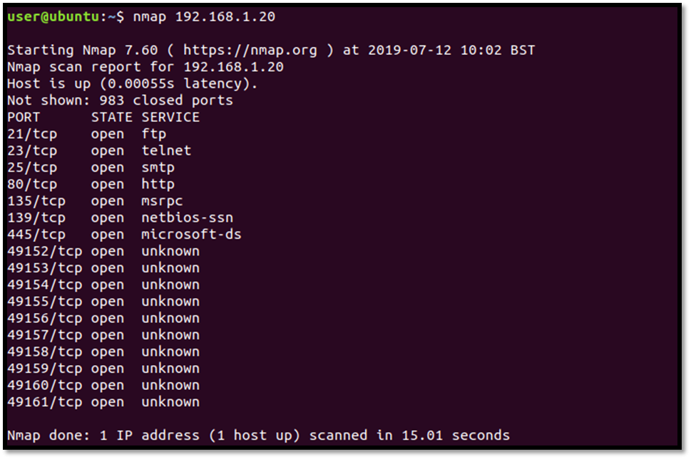

Determine the actual service running on each port by running the command “nmap –sV 192.168.1.20”

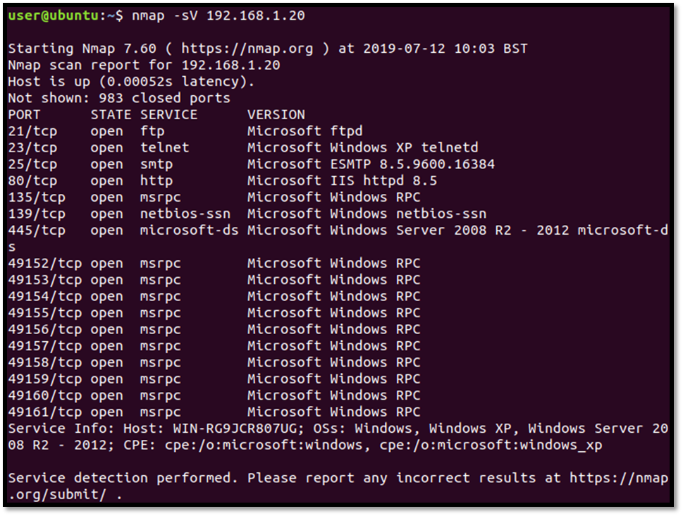

Run the command nmap 192.168.1.10 to identify the open ports on the Windows 10 machine.

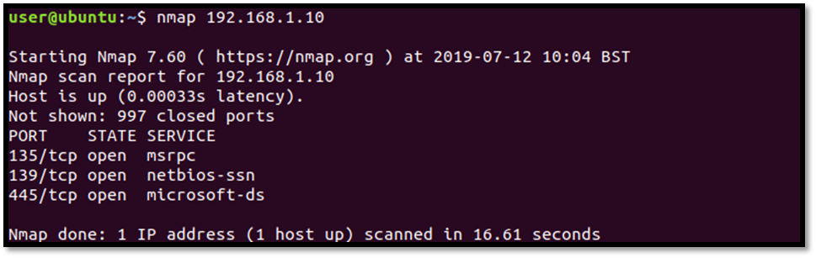

Run the command nmap –sV 192.168.1.10 to identify theactual service running on the open ports.

